Washington Township High School
Science National Honor Society
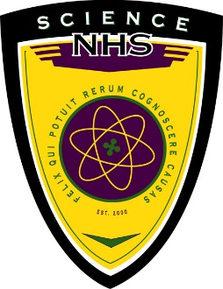

Teacher Evaluations Request

Students: Please fill out the top portion of this form and give it to the science teacher whom you would like to complete your recommendation before the due date of November 14, 2025. Later forms will not be accepted.

The teacher will complete the recommendation and return the form to Mrs. Howard or Ms. Cardamone.

Name of Student: __________________________ Homeroom #: ___________

Name of Teacher Requesting Recommendation from: ______________________

Course and Level Taught by Teacher: ____________________________________

Recommendation (Completed by Science Teacher):

- I recommend this student for Science National Honor Society
- I do not recommend this student for Science National Honor Society

Comments:

Science Teacher, please return this form to Mary Howard or Angela Cardomone. Thanks!

Signature: ________________________________________ Date: _______________

